Xoel Controle – Alterar meu plano

;change-number 5511944097230

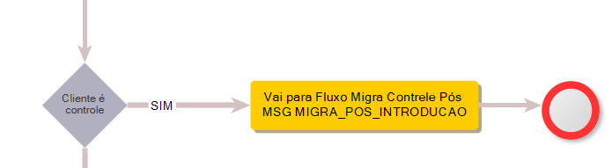

------------- teste 2

Outro controle ;change-number 5511944098475

